EyeDropAlarm is an app to track your drops  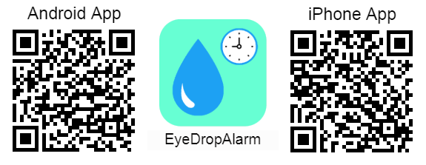 |  | EyeDropAlarm is an app to track your drops |  | EyeDropAlarm is an app to track your drops
EyeDropAlarm is an app to track your drops |  | EyeDropAlarm is an app to track your drops |  | EyeDropAlarm is an app to track your drops
EyeDropAlarm is an app to track your drops |  | EyeDropAlarm is an app to track your drops |  | EyeDropAlarm is an app to track your drops
EyeDropAlarm is an app to track your drops |  | EyeDropAlarm is an app to track your drops |  | EyeDropAlarm is an app to track your drops
EyeDropAlarm is an app to track your drops |  | EyeDropAlarm is an app to track your drops |  | EyeDropAlarm is an app to track your drops
EyeDropAlarm is an app to track your drops |  | EyeDropAlarm is an app to track your drops |  | EyeDropAlarm is an app to track your drops
EyeDropAlarm is an app to track your drops |  | EyeDropAlarm is an app to track your drops |  | EyeDropAlarm is an app to track your drops
EyeDropAlarm is an app to track your drops |  | EyeDropAlarm is an app to track your drops |  | EyeDropAlarm is an app to track your drops
EyeDropAlarm is an app to track your drops |  | EyeDropAlarm is an app to track your drops |  | EyeDropAlarm is an app to track your drops
EyeDropAlarm is an app to track your drops |  | EyeDropAlarm is an app to track your drops |  | EyeDropAlarm is an app to track your drops

